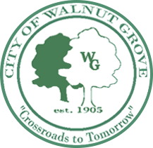

City of Walnut Grove
COUNCIL WORK SESSION AGENDA
Thursday, September 24, 2020
2:30 P.M.
Walnut Grove Municipal Building
1021 Park Street and via-teleconference

- CALL TO ORDER
- INVOCATION
- PLEDGE OF ALLEGIANCE
- COMMUNITY INVOLVEMENT COMMITTEE/CHRISTMAS TREE CELEBRATION

  - ATHLETE OF THE WEEK

- ISLAND PROPERTY UPDATE (Jesse Couch)
- CREATION OF RECREATION & PARKS COMMITTEE
- ADJOURN

